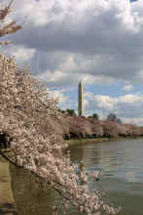

Staff Meeting Agenda
April 7, 2003
9:05 AM

- Senior Staff Reports
  - Near – term Priorities Malcolm
  - Finance Update Pablo
- General Program Update
- Resource Development Update Rich
- Partnership Development Update Matt

- Trip Reports

- Mexico Matt
- Jessica New Jersey
- New York Peggy
- Bolivia Malcolm

3. Program Update

- Colombia Anne

4. Other

- Building Update Pablo

Munchies for this meeting were provided by the Partnership Development Team!

